**RESULT ANALYSIS SYSTEM**

**A report submitted in partial fulfillment of the requirements**

**Of**

**Mini-Project (ISL64)**

**In**

**Sixth Semester**

**By**

|  |  |
| --- | --- |
| **1MS17IS059** | **M.BharatKumar** |
| **1MS17IS011** | **Akash K Hegde** |
| **1MS17IS007** | **Aditya K** |
| **1MS17IS012** | **Akash S Tonse** |

**Under the guidance of**

**Dr. Megha. P. Arakeri**

Associate Professor

Dept. of ISE, RIT



RAMAIAH

Institute of Technology

**DEPARTMENT OF INFORMATION SCIENCE & ENGINEERING**

**RAMAIAH INSTITUTE OF TECHNOLOGY**

(AUTONOMOUS INSTITUTE AFFILIATED TO VTU)

M. S. RAMAIAH NAGAR, M. S. R. I. T. POST, BANGALORE – 560054

**2019-2020**

**Acknowledgement**

We would like take this opportunity to thank everyone whole heartedly who helped us in the project. We are very much thankful to our principal Dr. N V R Naidu for providing us the facilities to carry out our project work. We extend our hand to thank our HOD, Dr. Vijay Kumar B.P, Professor and Head, Department of Information Science Engineering. We also wish to express our gratitude to our project guide, Associate Professor Dr. Megha P Arakeri, who was abundantly helpful and offered invaluable assistance exemplary guidance and constant encouragement. We would also like to thank all teaching and non-teaching staff of our department for their kind cooperation.

**Abstract**

When result is declared from the examination department many analysis has to be done by the department staff to retrieve some important data which is used to track the overall academic performance the result analysis may be for a particular semester or for a whole academic year its difficult to analysis this by hand or manually. But in our collage we found that the data has been analyzed manually by our staff which will take a lot of time and will also provide grounds to human errors which will reduce the efficiency and accuracy of the analysis result.

So we came up with a idea to provide software based solution to this problem by designing a web based application which does many of the analysis like number of fails, number of backlogs, the trend of evaluation in each subject, subject wise comparison of marks and grades, number of students who have acquired a particular grade, comparison between two batches results and many more both in graphical and numerical forms.

We use reactJS for the front end design and backend design and CanvasJS for the analysis of the data, input is taken in the form of excel files.

**Contents**

1. **Introduction** 6

1.1 Motivation 6

1.2 Scope 7

1.3 Objectives 7

1.4 Proposed Model 8

1.5 Organization of Report 8

**2.** **Literature Review** 9

**3.** **System Analysis and Design** 11

3.1 System Analysis 11

3.2 Operating Environment (Platform) 12

3.4 Technology Stack 12

3.5 Design 12

**4.** **Modelling and Implementation** 19

4.1 Use Case Diagram 19

4.2 Sequence Diagram 20

**5.** **Testing, Results and Discussion** 21

5.1 Testing 21

5.2 Results 23

5.3 Discussion 30

**6.** **Conclusion and Future Work** 31

6.1 Conclusion 31

6.2 Future Work 32

**Bibliography** 33

**List of Figures**

**Figure1 :** Input Format…………………………………………………………………………………………….13

**Figure 2 :** Number Of Backlogs……………………………………………………………………………........14

**Figure 3 :** Grades For Each Subject……………………………………………………………………….......14

**Figure 4 :** Uniform Distribution Graph………………………………………………………………………15

**Figure 5 :** Highest Mean and Lowest…………………………………………………………………………15

**Figure 6 :** Backlogs Data…………………………………………………………………………………………..16

**Figure 7 :** Comparison of Backlogs……………………………………………………………………………16

**Figure 8 :** Comparison Of Grades ……………………………………………………………………………..17

**Figure 9 :** Comparison Of Mean Marks………………………………………………………………………17

**Figure 10 :** Use Case Diagram ……………………………………………………………...19

**Figure 11 :** Sequence Diagram………………………………………………………………………………….20

**Figure 12 :** First Data Set with limited amount of students………………………………………..21

**Figure 13 :** Data set with all the students in the semester …………………………………………22

**Figure 14 :** Final data set with all 8 semester and marks included……………………………..22

**Figure 15 :** no of fails in testing phase 1……………………………………………………………………23

**Figure 16 :** Grades for each subject in phase 1…………………………………………………………..23

**Figure 17 :** Uniform Distribution Graph in Phase 1……………………………………………………24

**Figure 18 :** No of Fails in phase 2………………………………………………………………………………24

**Figure 19 :** Grades for Each Subject in Phase 2………………………………………………………….25

**Figure 20 :** Uniform Distribution Graph in Phase 2……………………………………………………25

**Figure 21** Number of Backlogs in phase 3…………………………………………………………………26

**Figure 22 :** Grades for Each subject in phase 3…………………………………………………………..26

**Figure 23 :** Uniform Distribution graph phase 3………………………………………………………..27

**Figure 24 :** Highest mean and lowest marks phase 3………………………………………………….27

**Figure 25 :** Backlog Data phase 3………………………………………………………………………………28

**Figure 26 :** Comparison of backlogs phase 3……………………………………………………………..28

**Figure 27 :** Comparison of grades phase 3………………………………………………………………...29

**Figure 28 :** Comparison of mean marks phase 3………………………………………………………..29

**Chapter 1**

# **Introduction**

This includes a detailed introduction to our project where we have discussed about the complete project in brief. This section contains motivation, scope of the project along with our objective and details of our proposed model, it also has the organization of report to give a brief idea of what this report has.

## Motivation

The teaching faculty of various institution still perform most of the post-result analysis by hand due to the limitations and lack of computer software available to them. This primarily leads to the analysis being really tedious and time consuming and mostly, also limits the different analysis that could be done on the available data.

The teaching faculty is usually expected to check the accuracy of correction in the obtained results for each semester and also may be asked to check the trend of student performance for a particular subject over the past few years. Proctors are expected to have a complete log of their students’ results and their examination history. Teachers are expected to monitor student performance year after year, in each subject. This translates to a lot of man hours and tedious paperwork which can be eliminated with a functional application.

We intended to develop an application which is easy to use by any faculty member dealing with the results of students. The user, with this application, must be able to receive all the analysis and visualization on the data required by just uploading a standard dataset of the students’ results.

The proposed solution uses ReactJS for the website and implements data visualization using Canvas.

## Scope

1. Aims to reduce the time taken by faculty to analyze the result published by the examination department.
2. Reduces the error and increases the accuracy and precision in the result analysis process.
3. Displays graphically and numerically:- number of students who have acquired a particular grade, number of students failed in particular subject, how the correction trend is, subject wise comparison of the result.
4. Displays number of students having backlogs in a particular semester, in a particular year and also until the complete duration of course and displays how many backlogs a student has individually.
5. We are also able to compare results of 2 batch of students which includes 4 years data each which would be a tedious work without the software.

## Objectives

1. To allow the faculty to obtain analysis on the results by uploading result sheets in the same format followed by the university. It is important for the application to run on a standard result sheet without the user having to make much changes to ensure a quick and hassle free experience.

2. To help the faculty keep track of the number of students failed in each subject in every semester. They should also be able to check the previous backlogs of these students.

3. To allow the user to upload the results of different semesters and analyze student performance over the course of time for any particular subject.

4. To compare data of two complete batches of student to allow the faculty to analyze marks trends and mistakes and also improve performance.

## Proposed Model

The solution which we proposed will be a web based application which will be doing all the analysis part of the result. We can give a single semester’s data a complete years data or even the data of the all four years. The data should be in the form of excel sheets with each sheet containing data of a particular semester. We use reactJS for analysis, the excel files will be converted into JSON traversing is done and desired information is stored in the form of dictionary. Then we use canvasJS to visualize the data in the form of graphs and also print the necessary data with text and numerical format.

## Organization of Report

In order to explain the developed system, the following sections are covered:

* **Literature Review** describes the study of the existing systems and techniques taken into account prior to development of the proposed system.
* **System Analysis and Design** provides a detailed walk through of the software engineering methodology adopted to implement the model, an overview of the system and the modules incorporated into the system.
* **Modelling and Implementation** provides a deeper insight into the working of the model. The various modules and their interactions are depicted using relevant descriptive diagrams.
* **Testing** the model to ensure bug/error free model along with the **Results** obtained. **Discussion** then provides detailed analysis on quality assurance measures.
* **Conclusion** about the Results obtained after successfully running the model and **Future Scope** of the model is highlighted.

**Chapter 2**

# **Literature Review**

In this section of the report we are referring some literature papers which is similar or related to our project. We have found out some disadvantages or limitation in this papers which we have solver or overcome in our project

Ashwin Mehta et al. [1] implemented Student Result Analysis System by taking result published in the form of excel sheet and analyzing using JavaScript proposed a model which analysis result comparing individual student but no subject wise analysis or overall analysis is done but we have implemented overall analysis and subject analysis in our model.

Shubhangi Shankar Shinde et al. [2] proposed Result Analysis of Choice Base Credit System a model which calculates the result of a student by evaluating the internal assessment and external assessment results and calculates credit based result which is common in most of engineering collages but has no provision for subject wise semester wise or overall analysis.

Nivetha Shri et al. [3] Implemented Android Student Result Analyzing System, result analysis using android app which proposes limitation such as it cannot be used in personal computers we overcome this problem by developing a web application which is platform independent i.e. can run on both personal computers and mobile phones.

Bhushan Dashpute et al. [4] proposed Credit Based Result Analysis System By Extracting Data From Pdf, a model of result analysis of the student using input file which is in the form of pdf and also states pdf is the most used file format now a days but here we should note that the result published by 95% of the institutes will be in excel sheets so we have implemented excel sheets in our model.

Akpasam Josep et al. [5] implemented Students Result Management System, results analysis of all categories of students but here they have asked for registration for each and every users. Registration asks for many information and takes time to complete and some people might not want to give their details in registration so our platform is free from this if you have the data you can have the analysis result.

Chew Li Sa et al. [6] proposed Student performance analysis system, a result analysis system where no access is given to lecturers, only deans and deputy deans have access we have solved this problem by giving access to all the faculty members along with deans, principals and management members.

Nikhil Gupta et al. [7] proposed Student result analysis and performance report generator, a model where data input is taken in form of pdf file as exam departments of most of the collages produce the result sheet in form of excel pdf won’t be a useful format so we have used excel sheet as our input format.

K. Himaja. et al. [8] proposed Result analysis automation , a system similar to our software but it only produces the report of students no comparison is done among semester, subjects or batches we have solved this problem by providing provisions for comparative analysis.

Pankaj Sambyal et al. [9] proposed Result Analysis suit, a model which retrieves data from the examination department, re-organizes it and displays it the lecturers and students no provision is provided for comparison and mass comparison where as our model has ability to compare a large quantity of data.

Dhawal P Atkara et al. [10] has proposed Design and implementation of result analysis system for collages, a system similar to our system which also has the analysis provision in it but it does not have provision for comparison between two whole batches but our project has provision for comparison of batch of students.

**Chapter 3**

# **System Analysis and Design**

This includes the system analysis i.e. how we have built the project, the libraries used the technological stack used in the project, how is our design and the input and output format along with the operating environment of the project.

## 3.1 **System Analysis**

This includes the software’s, libraries, packages and analysis tools used in both front end and back end of the project.

* **React :-** The entire application is built in React also known as React.js or ReactJS which is a [JavaScript library](https://en.wikipedia.org/wiki/JavaScript_library)for building [user interfaces](https://en.wikipedia.org/wiki/User_interfaces). It is maintained by [Facebook](https://en.wikipedia.org/wiki/Facebook) and a community of individual developers and companies. React can be used as a base in the development of [single-page](https://en.wikipedia.org/wiki/Single-page_application) or mobile applications. However, React is only concerned with rendering data to the [DOM](https://en.wikipedia.org/wiki/Document_Object_Model).
* **CanvasJS** **:-** We use this for data visualisation CanvasJS was first released in March 2013 and there has been continuous enhancements since then. It has a simple API and provides 10x better performance than SVG based Charting Libraries. You can also integrate it easily with popular front end frameworks.
* **Cascading Style Sheets** (**CSS**) **:-** It is a [style sheet language](https://en.wikipedia.org/wiki/Style_sheet_language) used for describing the [presentation](https://en.wikipedia.org/wiki/Presentation_semantics) of a document written in a [markup language](https://en.wikipedia.org/wiki/Markup_language" \o "Markup language). CSS is a cornerstone technology of the [World Wide Web](https://en.wikipedia.org/wiki/World_Wide_Web) we have used this to style our GUI and front page.
* **npm (Node Package Manager) :-** is a [package manager](https://en.wikipedia.org/wiki/Package_manager) for the [JavaScript](https://en.wikipedia.org/wiki/JavaScript) programming language. It is the default package manager for the JavaScript runtime environment [Node.js](https://en.wikipedia.org/wiki/Node.js). It consists of a command line client, also called npm, and an [online database](https://en.wikipedia.org/wiki/Online_database) of public and paid-for private packages, called the npm registry.

## 3.2 **Operating Environment (Platform)**

As our application is a web based application, it runs smoothly on all operating systems until the device is well connected with the internet React supports all popular browsers, including Internet Explorer 9 and above, although [some polyfills are required](https://reactjs.org/docs/javascript-environment-requirements.html) for older browsers such as IE 9 and IE 10. It don’t support older browsers that don’t support ES5 methods, but you may find that our apps do work in older browsers if polyfills such as [es5-shim and es5-sham](https://github.com/es-shims/es5-shim) are included in the page. You’re on your own if you choose to take this path.

## 3.4 **Technology Stack**

* ReactJS
* Node packet manager (npm)
* HTML and CSS
* Node modules
* React-router-dom
* CanvasJS

## 3.5 Design

This includes the design of the software along with input and output formats explained in details along with detailed pictures.

**3.5.1 Input Format**

Input is taken in form of excel files as provided or published by the examination department where students name and USN is displayed in the first 2 columns with the grades obtained and marks obtained in each subject Infront of them the column header has the subject code and subject name. There will be multiple sheets in a single file which will be of the same format and each sheet contains marks result of a particular semester. Its shown in the figure 1 displayed below.

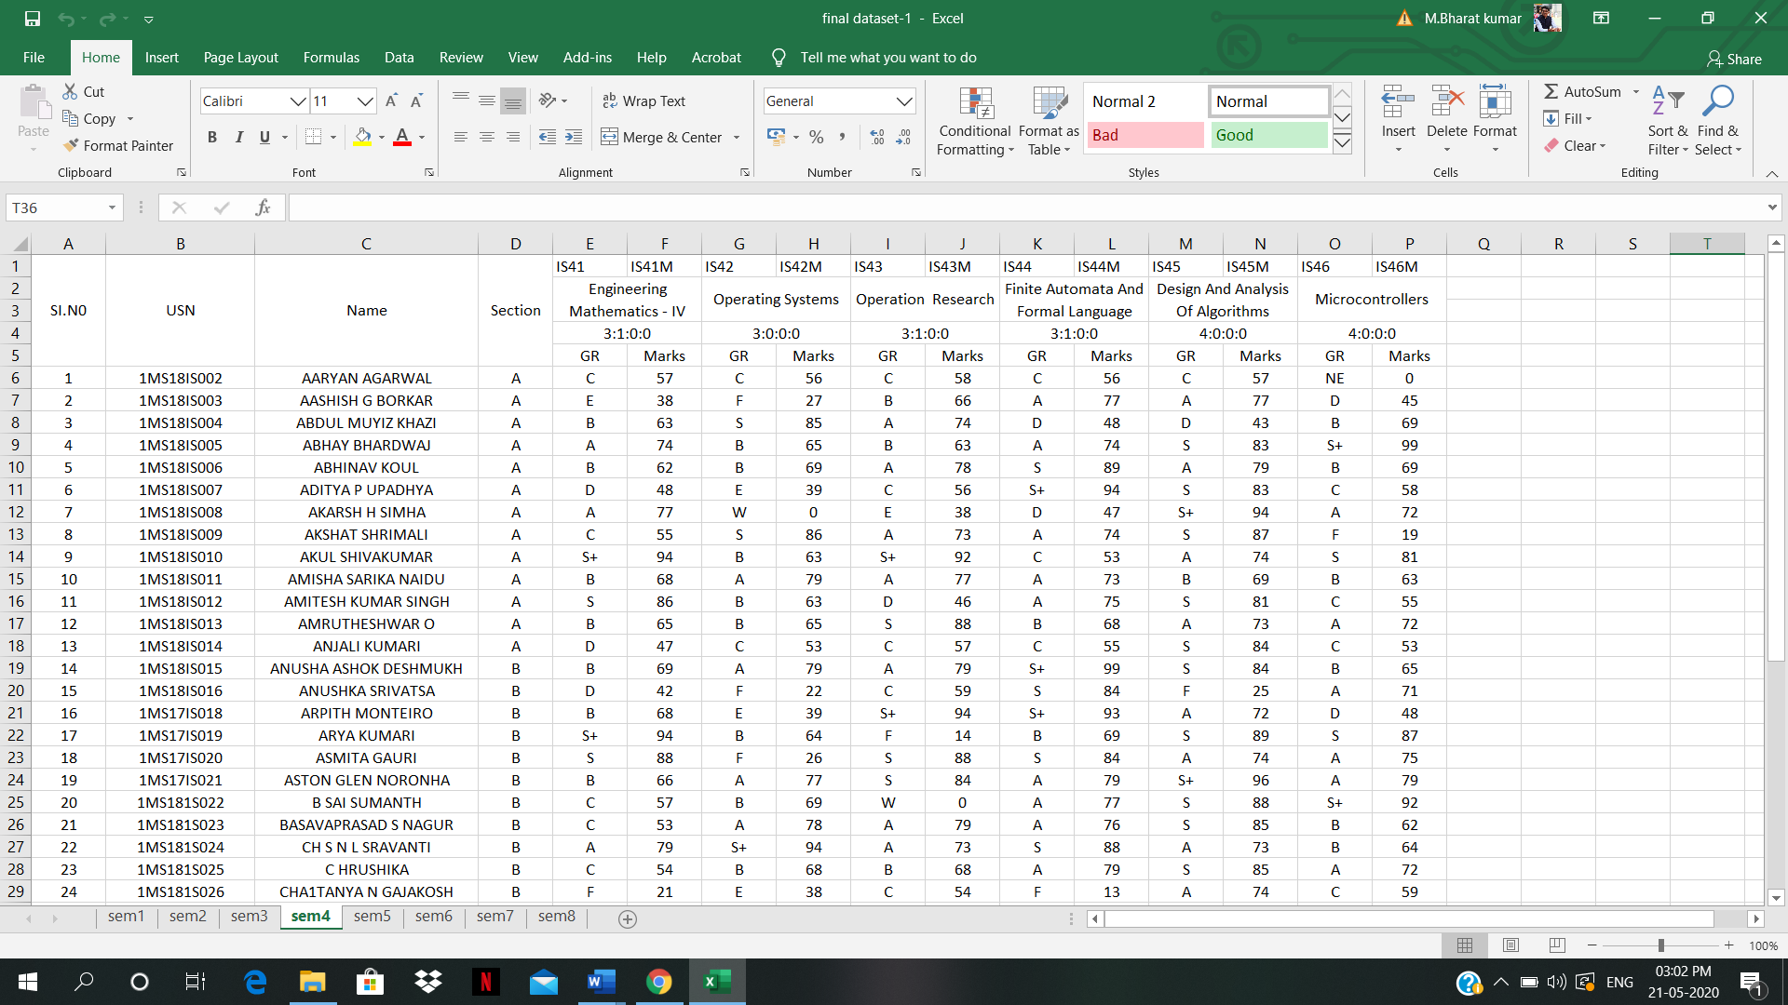

**Figure1 :** Input Format

**3.5.2 Output Format**

Output will be in the form of data visualisation (graphs) and values displayed in text and number. It will include number of fails in each as in subject in each semester as in figure 2, number of students who have acquired a particular grade in each subject separately for each semesters as in figure 3, graph representing trend in evaluation in each semester as displayed in figure 4, maximum, minimum and average marks in each subject along with subject wise comparison which is displayed in figure 5, number of backlogs for each semester and overall subtotal of backlogs along with names of students who have backlogs which is displayed in figure 6. It also has comparison of two complete batch of students which includes 4 years of data for 1 batch which is displayed in figure 7.

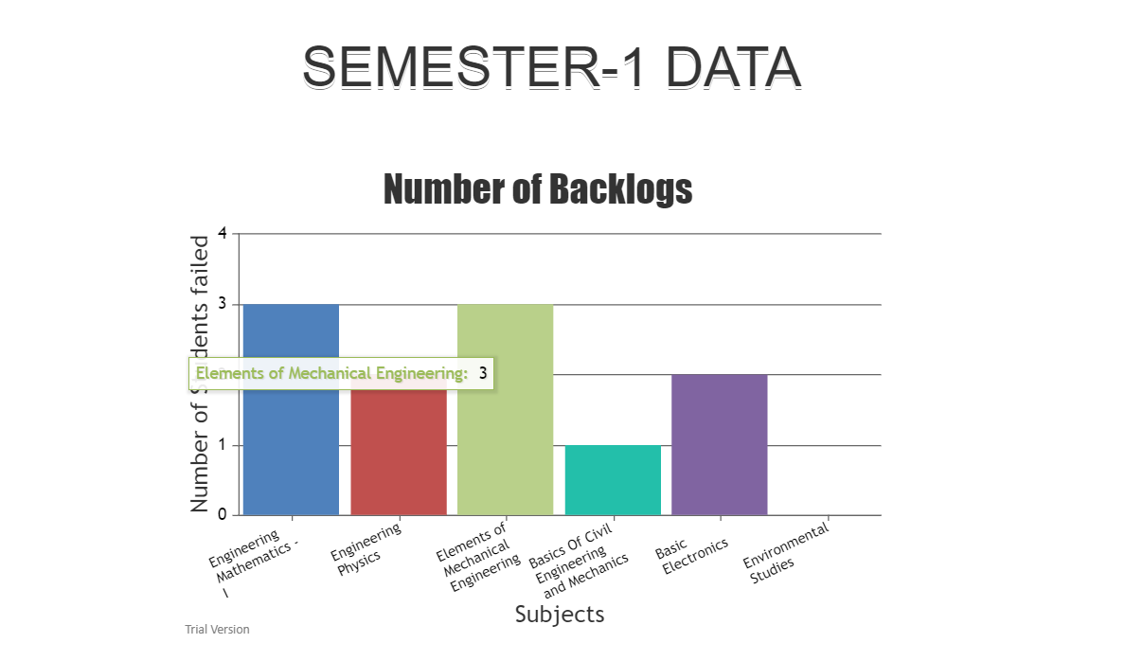

**Figure 2 :** Number Of Backlogs

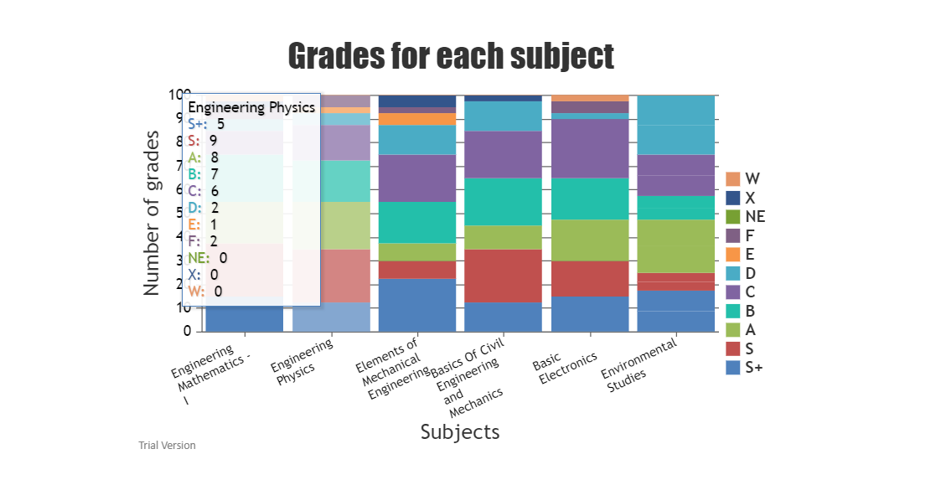

**Figure 3 :** Grades For Each Subject

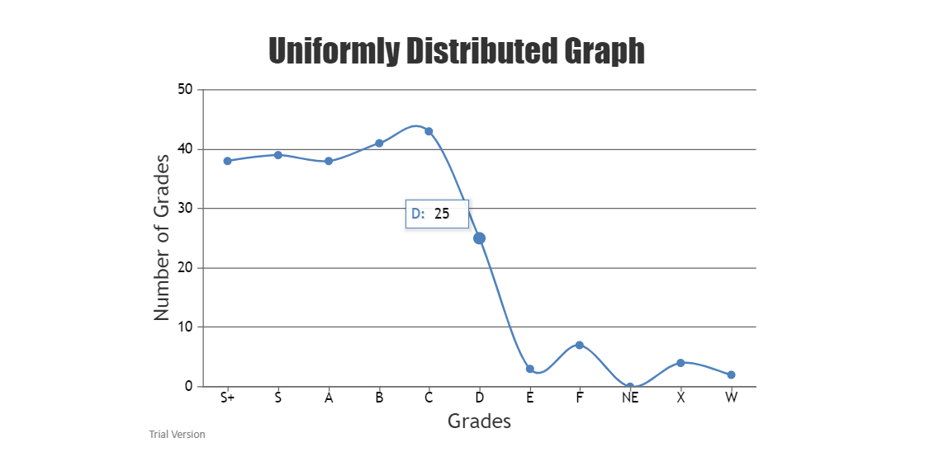

**Figure 4 :** Uniform Distribution Graph

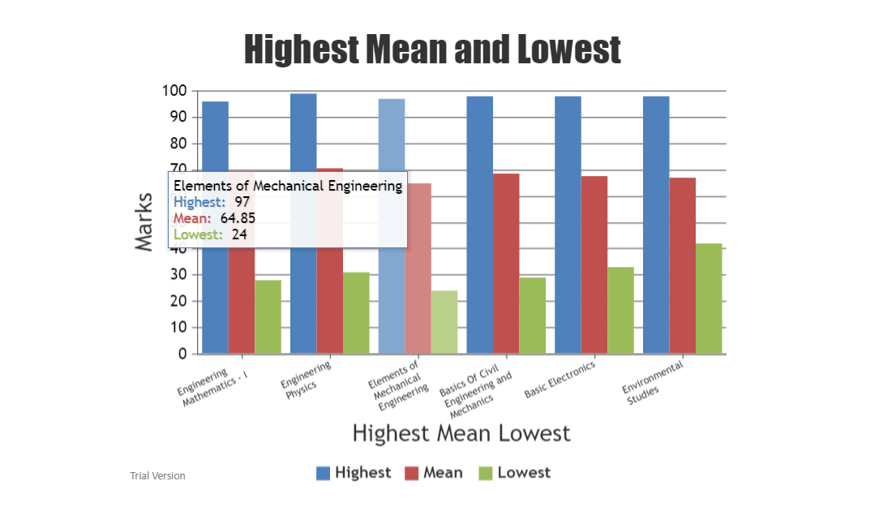

**Figure 5 :** Highest Mean and Lowest

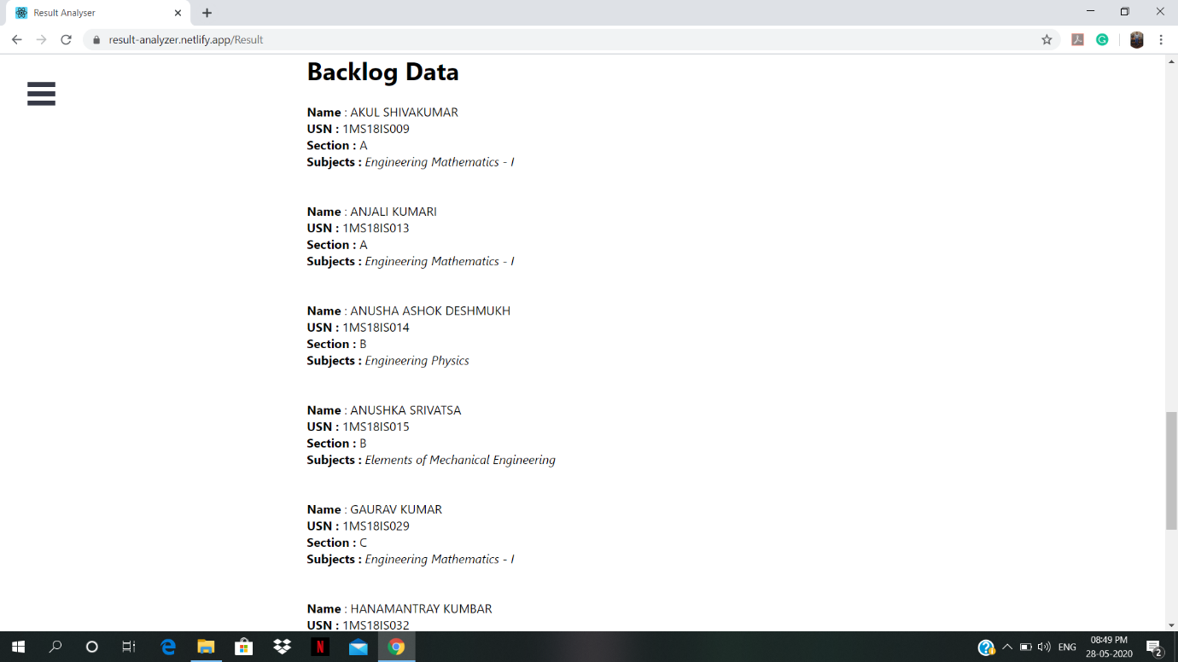

**Figure 6 :** Backlogs Data

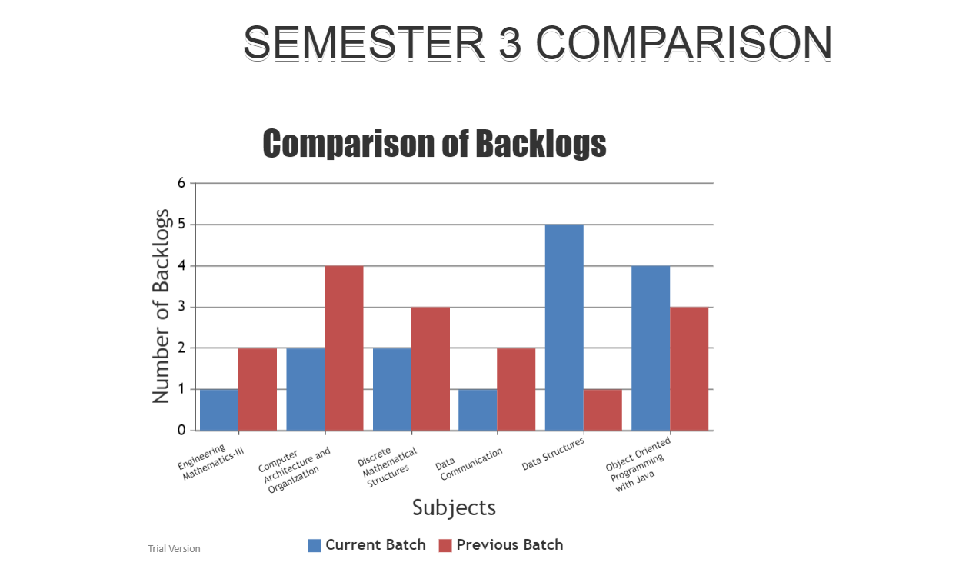

**Figure 7 :** Comparison of Backlogs

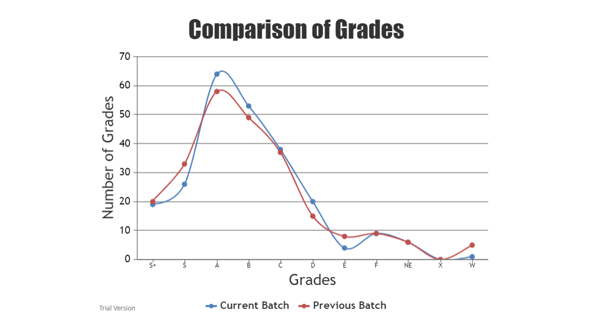

**Figure 8 :** Comparison Of Grades

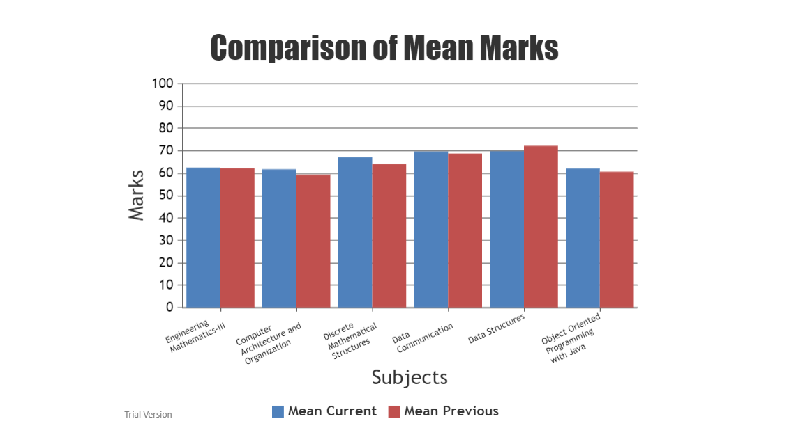

**Figure 9 :** Comparison Of Mean Marks

**3.5.3 Analysis Process**

The excel file which is taken as input is converted to JSON format and then traversal is done through the file subject by subject. Dictionary format is used to store all the extracted information for further use, subject code is used as the key and student USN is used as the key while counting backlogs, this ensures no repeated entries are allowed, integer are used to count quantitative values, the integer is incremented depending on the cases as we traverse through the document and the final result is displayed on the browser screen with the help of CanvasJS for data visualisation i.e. graph and numbers and text for the other important data.

**Chapter 4**

# **Modelling and Implementation**

This section contains the use case diagram and sequence diagram of the project which explain how the software works and how is the user interaction done with the software.

## Use Case Diagram

User uploads the excel file which has been published by the examination department, the excel file is converted to JSON object and then traversal is done throughout the file and necessary analysis result is saved in dictionary format which is given as an input to CanvasJS and output i.e. analysis result is displayed to the user. The whole process is shown in figure 10

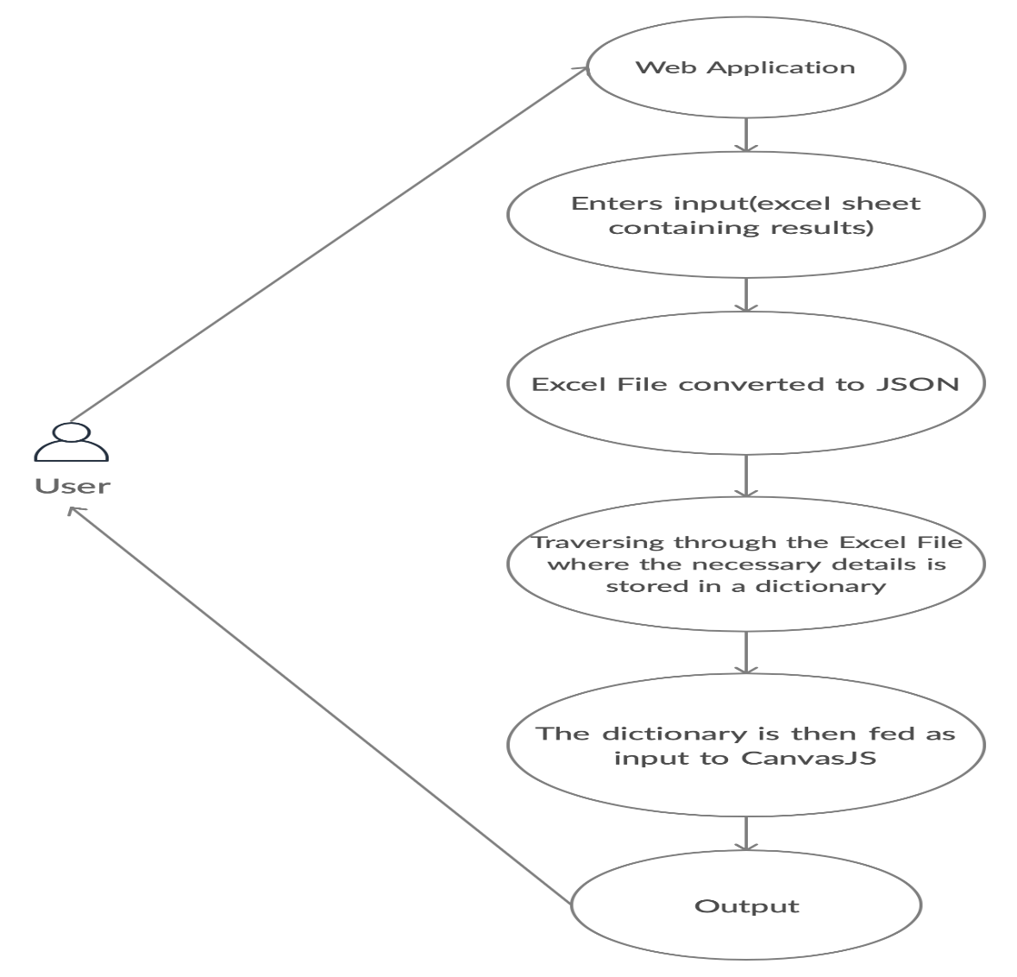

**Figure 10 :** Use Case Diagram

## 4.2 Sequence Diagram

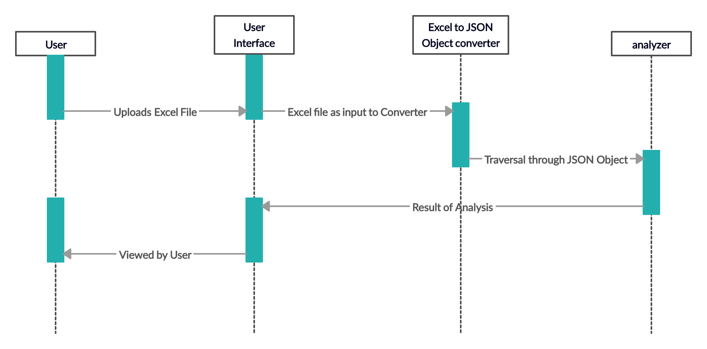

**Figure 11 :** Sequence Diagram

The user interacts with the interface where he uploads the excel sheet containing the result and hits on the process button which will fed the data sheet to excel to JSON object converter where it is converted to JSON object which is then fed to the main analyzer which traverses through the file retrieves the necessary information and processes the analysis report in form of data and data visualization which is then delivered to the interface for the user to view and copy. The complete sequence is shown in figure 11

**Chapter 5**

# **Testing, Results and Discussion**

This section has all the details of data set building, testing our software along with the results which we have got through our testing everything in details.

## 5.1 Testing

We tested our project with the data set containing results of students from one particular semester with a limited number of students. Data set is displayed in figure 12.

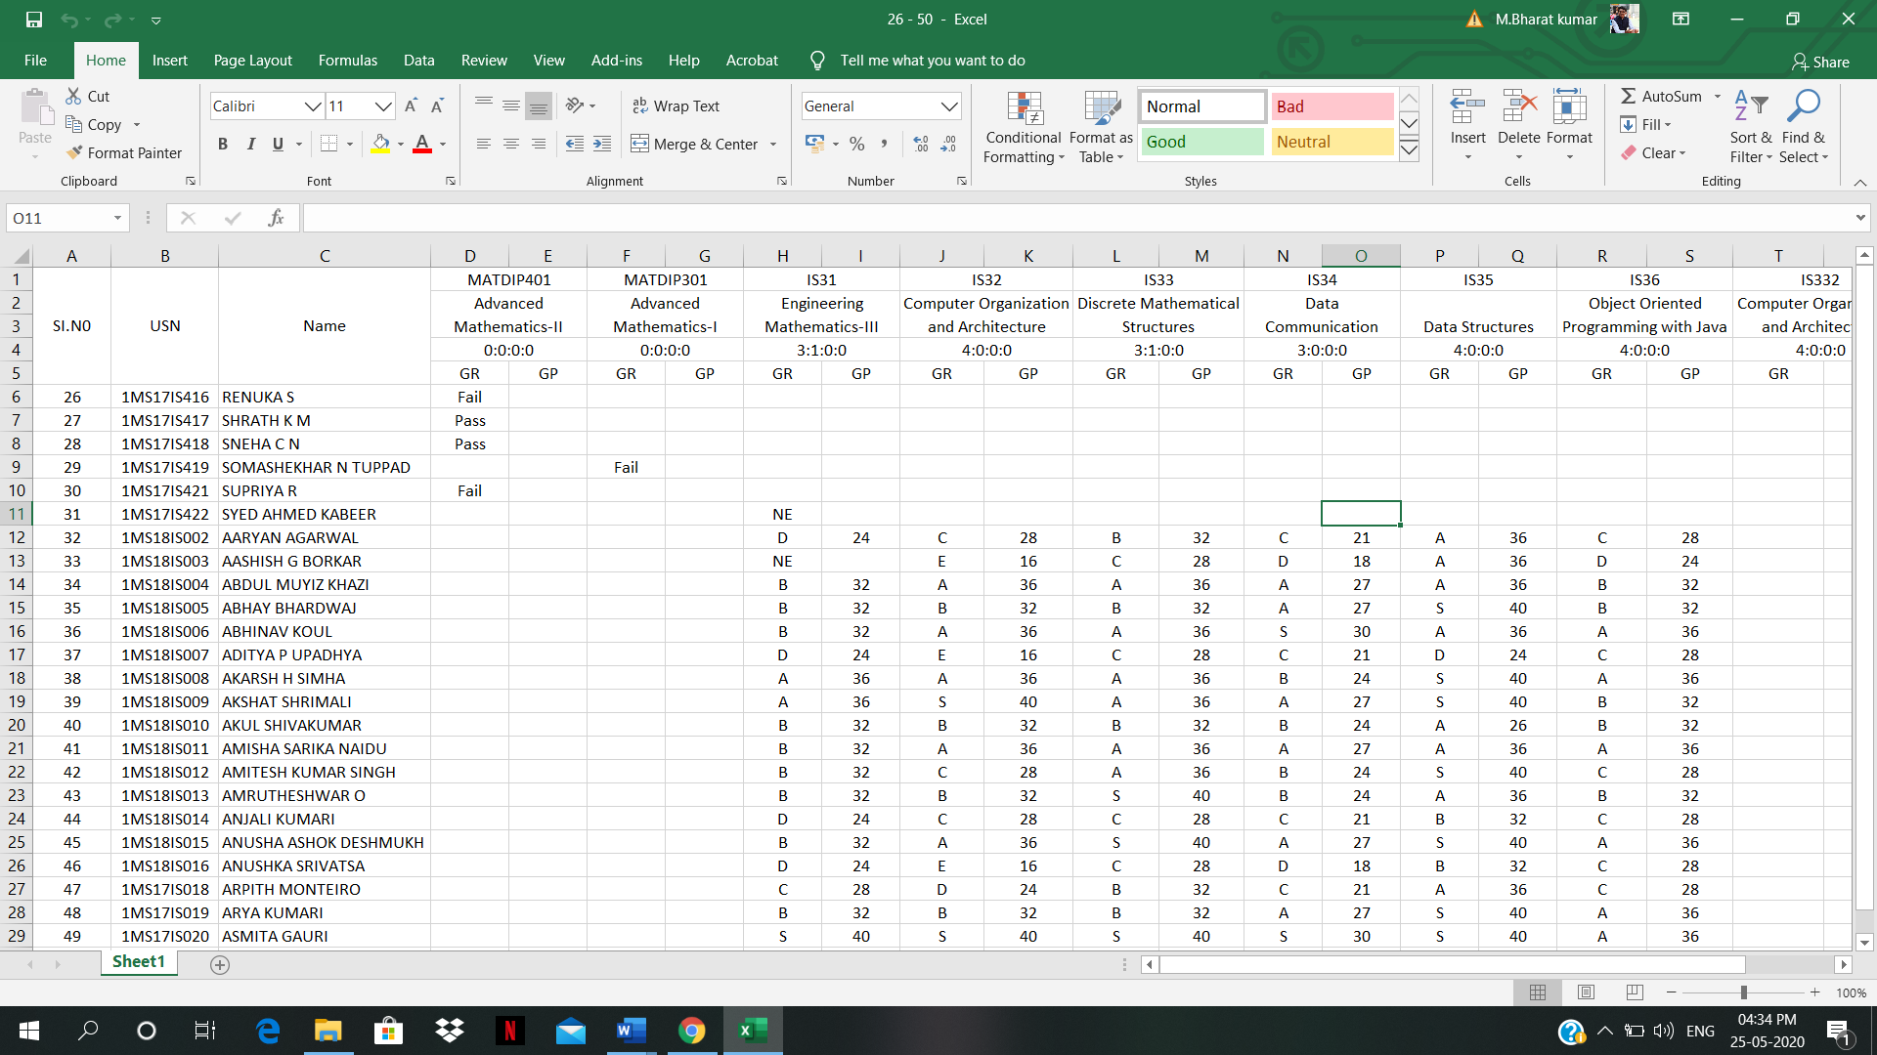

**Figure 12 :** First Data Set with limited amount of students

The we increased the number of students by including every student in the semester just to ensure our model can handle large amount of data. The data set is displayed in the figure 13 below.

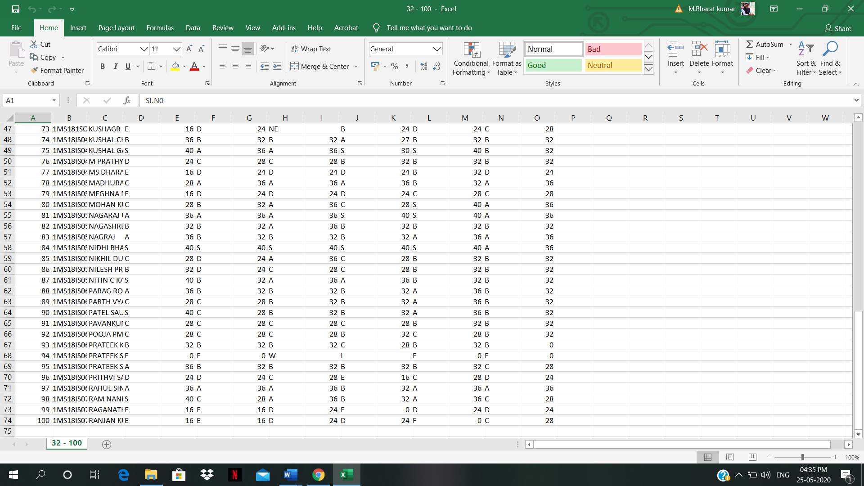

**Figure 13 :** Data set with all the students in the semester

Required correction was done to the model and the backlog count and analysis of marks along with grades features were added to the model and testing was done by inputting data of all eight semester, data set is displayed in figure 14.



**Figure 14 :** Final data set with all 8 semester and marks included

## 5.2 Results

We got the desired result but with some errors and limited features which were corrected and added in the further testing phase. Our results has been declared figure 15, 16, 17.

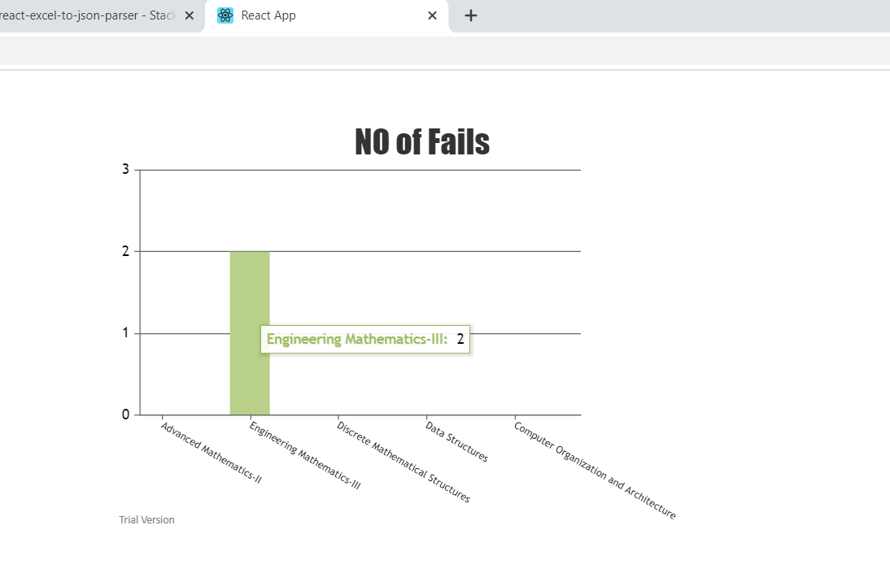

**Figure 15 :** no of fails in testing phase 1

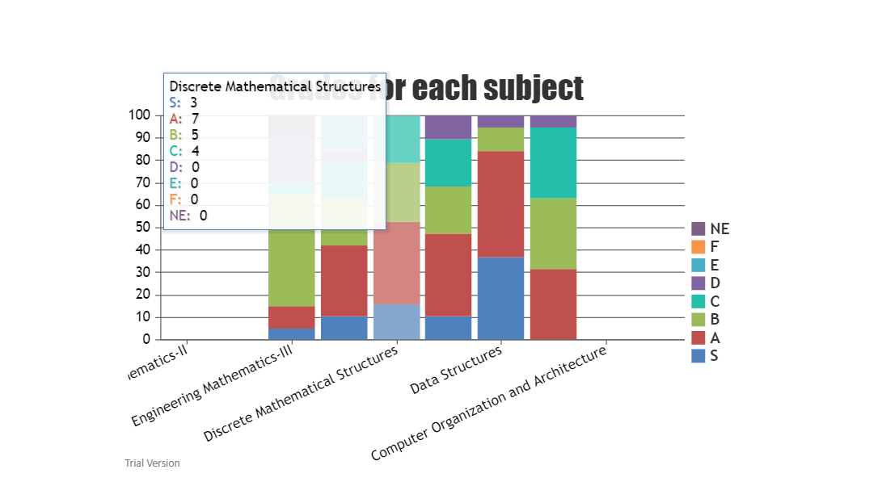

**Figure 16 :** Grades for each subject in phase 1

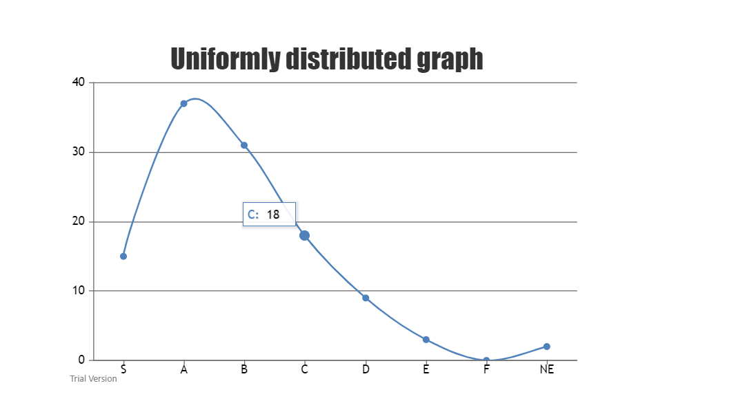

**Figure 17 :** Uniform Distribution Graph in Phase 1

The model was able to deal with big data and analyze it with the same speed without any delay features were kept limited even in this phase, additional features like backlogs and marks analysis were added in the next phase. Results has been displayed in figure 18, 19, 20.

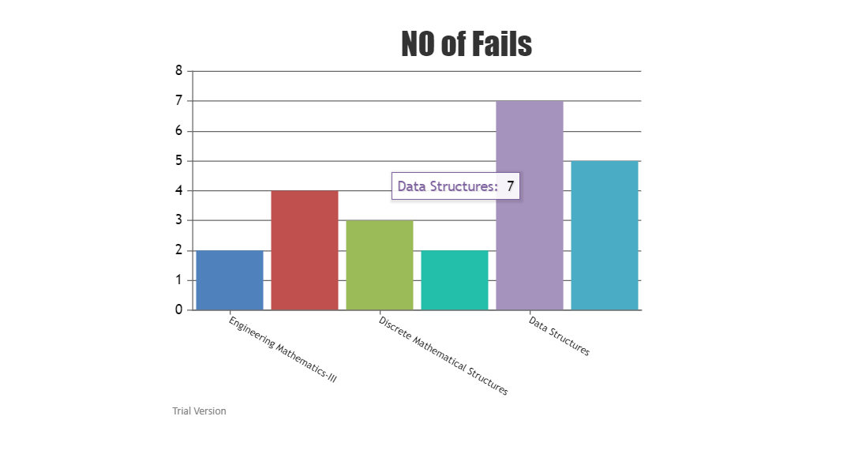

**Figure 18 :** No of Fails in phase 2

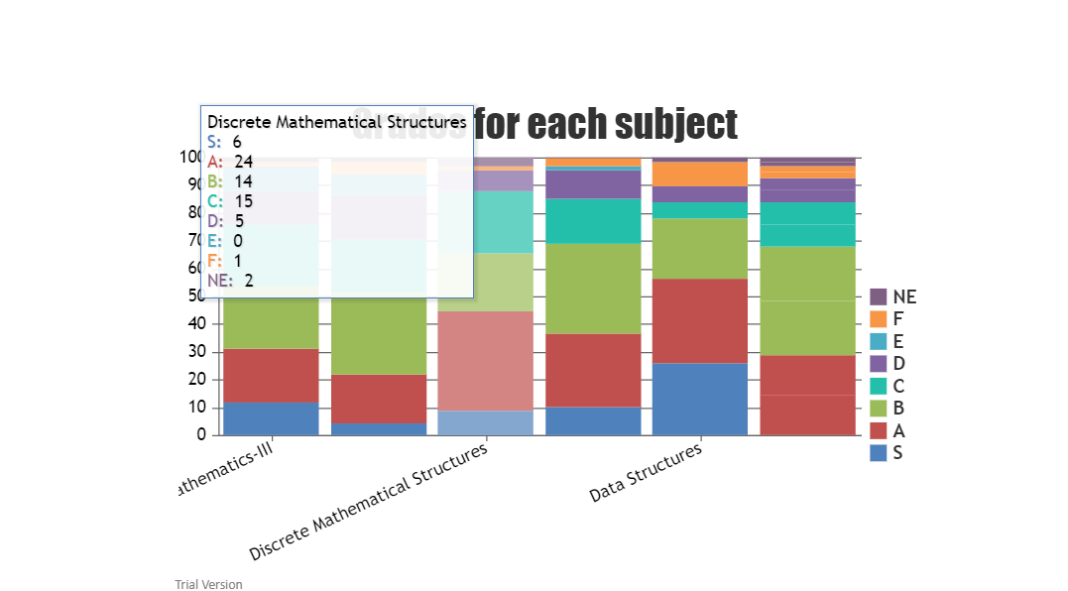

**Figure 19 :** Grades for Each Subject in Phase 2

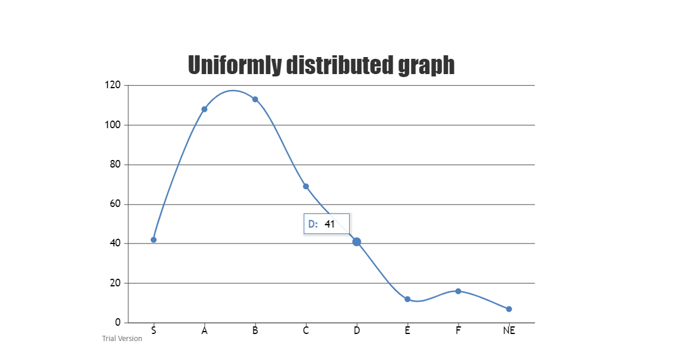

**Figure 20 :** Uniform Distribution Graph in Phase 2

This was the final testing where all the features were implemented and all semester marks were given as input and the model worked fine with all the data, giving all the desired output. All the errors encountered in the previous phase were corrected in this phase. All different results of phase 3 has been displayed in figure 20 to figure 27.



**Figure 21** Number of Backlogs in phase 3



**Figure 22 :** Grades for Each subject in phase 3



**Figure 23 :** Uniform Distribution graph phase 3



**Figure 24 :** Highest mean and lowest marks phase 3



**Figure 25 :** Backlog Data phase 3



**Figure 26 :** Comparison of backlogs phase 3



**Figure 27 :** Comparison of grades phase 3



**Figure 28 :** Comparison of mean marks phase 3

## 5.3 Discussion

To make the model best suitable for result analysis we have implemented almost all the requirement provided by the collage. The project was made to meet all the requirements in subsequent phases of testing. First the project was made tested to deal with small data providing limited analysis features as output then the model was tested to see weather it can withstand big data belonging to single semester, as no extra features were added to the model until this phase.

After the model was successfully tested in the phase we implemented all the other requirements such as counting and analysis of backlogs, adding marks to the data set and analyzing the marks, we also had some subject name labels missing in the previous phase which was corrected in this phase. After this phase model was ready to analyze any amount of data, it might be 1 semester, 1 year or all the 4 years, the software can analyze and provide all the necessary outputs of result analysis on the click of a single button.

**Chapter 6**

# **Conclusion and Future Work**

This section of report includes the goals achieved by our project and the conclusion of the project along with the future scope of the software.

## 6.1 Conclusion

We are able to save a lot of time for lecturers and are also able to reduce the work load on them as this process is tedious and cumbersome when done manually. We are able to reduce the possible human error which occurs during analysis and are able to increase the accuracy and precision in the analysis result. Data visualization which was not possible when done manually is available now with a click of button

When the analysis was done manually only limited information was retrieved but now we are able to retrieve a lot of other useful data from the result published. We are able to do comparative as well as qualitative analysis of subjects, performance and evaluation. We are able to displays graphically and numerically the number of students who have acquired a particular grade, number of students failed in particular subject, how the correction trend is and subject wise comparison of the result

We are also able to displays number of students having backlogs in a particular semester, in a particular year and also until the complete duration of course and displays how many backlogs a student has individually

## 6.2 Future Work

Following are the enhancements and future works of the project

* We have implemented marks in the result sheet which will be helpful if the examination department in future starts publishing marks obtained by students in the respective subject
* We can implement tracking and analyzing performance of individual student in each subject and guide him accordingly
* We are using the result sheet published by the examination department to retrieve data for analysis but we can implement retrieving data directly from examination department’s website if they permit us to gain access to the website
* It can be connected to collage website and data base where lecturers can login, access the data base of result related to their domain, analyze the result and store the data in their data base where as HOD and principal can view data related to the whole department and collage respectively

**Bibliography**

[1] Ashwin Mehta, Jugal Patel, Aditya Mewada. STUDENT RESULT ANALYSIS SYSTEM International Research Journal of Engineering and Technology (IRJET) e-ISSN: 2395-0056 p-ISSN: 2395-0072 Volume: 05 Issue: 04 | Apr-2018 page no. 1 – 3.

[2] Shubhangi Shankar Shinde , Dr. Bhatambrekar S.S. Dipali Meher. Result Analysis of Choice Base Credit System. International Research Journal of Engineering and Technology (IRJET) Apr-2016 page no 2 – 3.

[3] Nivetha Shri. Divya. Android Student Result Analyzing System (App Development). International Journal of Advance Research in Computer Science and Management Studies Volume 3, Issue 1, January 2015 ISSN: 232 7782 1 page no. 3 – 5.

[4] Dashpute, Vaskar Priyanka, Jadhav Karina, Ms. Yogita Desai, Bhushan. Credit Based Result Analysis System By Extracting Data From Pdf. International Journal for Research in Engineering Application & Management (IJREAM) Special Issue – ICRTET-2018 ISSN : 2454-9150 page no 2 – 4.

[5] Akpasam Joseph Ekanem, Simeon Ozuomba, Afolayan J.Jimoh. Development of Students Result Management System: University of Uyo DOI : 10.13140 /RG.2.2.15744.79360 page no 1 – 4.

[6] Nikhil Gupta. Student Result analysis and performance generator . Research paper (Undergraduate) 2019 page no 1 – 3.

[7] [Chew Li Sa](https://www.researchgate.net/scientific-contributions/2083024354_Chew_Li_Sa), [Dayang Hanani bt. Abang Ibrahim](https://www.researchgate.net/scientific-contributions/2083052347_Dayang_Hanani_bt_Abang_Ibrahim), [Emmy Hossain](https://www.researchgate.net/profile/Emmy_Hossain), [Mohammad Hossin](https://www.researchgate.net/profile/Mohammad_Hossin) Student performance analysis system (SPAS). January 2015 DOI: 10.1109/ICT4M.2014.7020662 page no 1 – 3.

[8] K. Himaja, lalam Sreevidya and N. Srinivasan. Result analysis and automation. ARPN Journal of Engineering and Applied Sciences. JULY 2017 ISSN 1819-6608 page no 1 - 3

[9] Pankaj Sambyal, Anamika Rustagi, Sonia Rani, Chinab Bhudhiraja, Bhawna Sharma Result Analysis Suite: A Completely Automated Result Analysis Solution. International Conference on Information Technology and Knowledge Management DOI: 10.15439/2018KM26 ISSN 2300-5963 2017 page no 2 – 3

[10] Dhawal P.Atkare, Swapnil M.Waghade, Sameer A.Javed, Anand Shanker. Design and Implementation of Result analysis system for collages. International Conference on Emanations in Modern Engineering Science & Management (ICEMESM) ISSN: 2395-1303 2018 page no 2

[11] Front end designing :-

[https://jecc.ac.in/kturesultanalysis/#](https://jecc.ac.in/kturesultanalysis/)

[12] Data visualization :-

<https://canvasjs.com/>

[13] ReactJS Tutorials :-

<https://www.youtube.com/playlist?list=PLC3y8-rFHvwgg3vaYJgHGnModB54rxOk3>

<https://reactjs.org/tutorial/tutorial.html>

[14] Resource for converting excel file to JSON object :-

<https://stackblitz.com/edit/react-excel-to-json-parser>